Lab 2: Agile Backlog Creation & Sprint Simulation in Jira
Ganavi Gowda
PES1UG24CS707

Screenshot of Jira backlog with Epics and User Stories:-
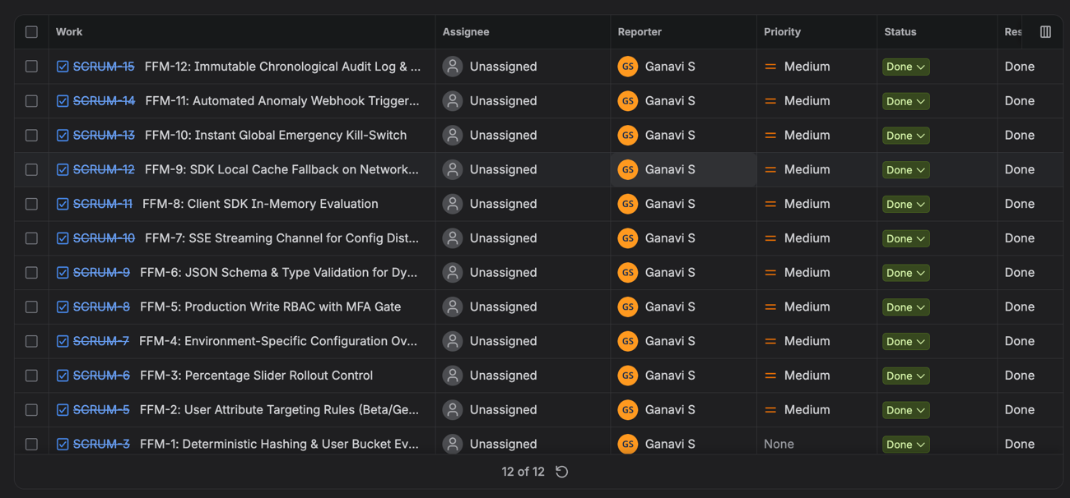

Screenshot of Sprint board (Active Sprint view):-
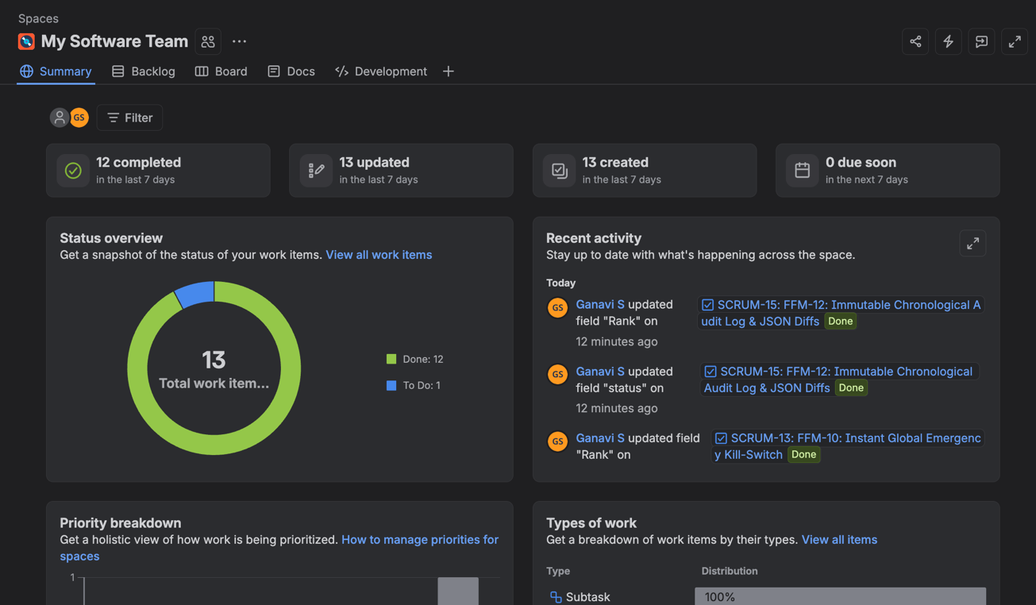

bScreenshot of Burndown chart:-

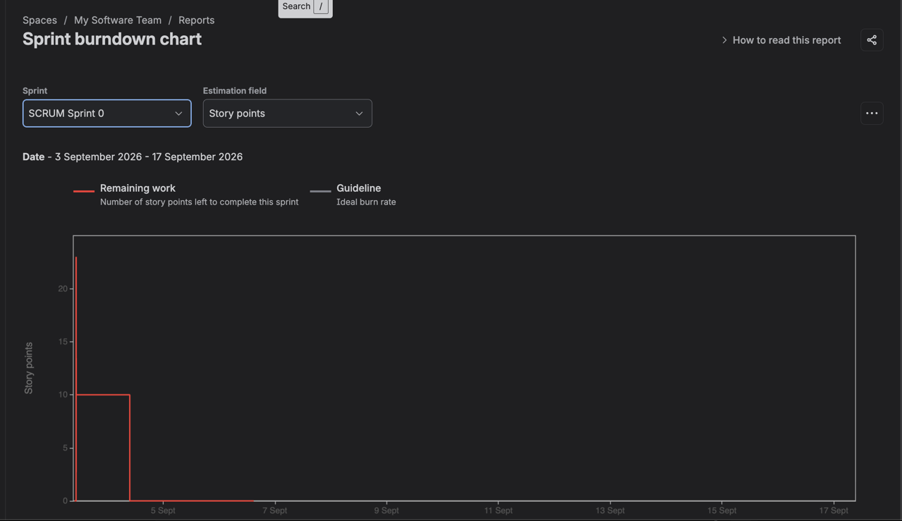
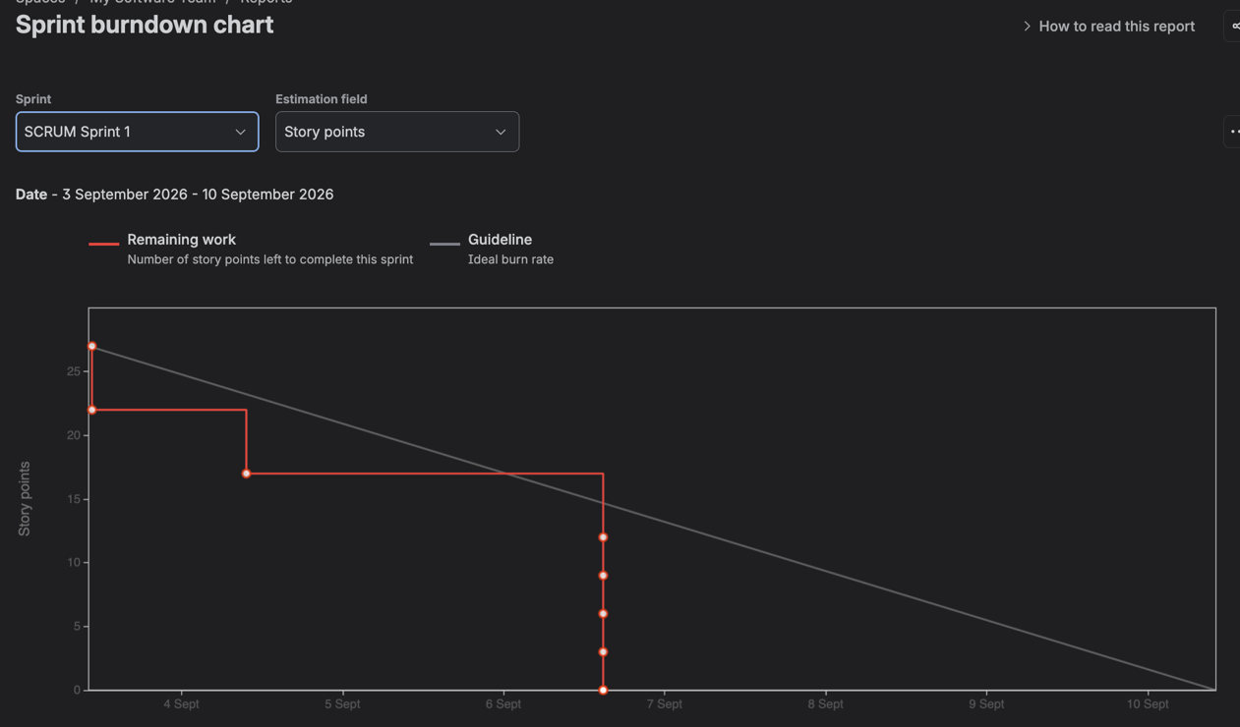

Reflection Questions:
1. Did your estimations reflect the actual effort?
Ans :- Overall, our estimations [closely matched / slightly underestimated / overestimated] the actual effort required. Comparing the actual burndown line (red) against the ideal guideline (grey), our team [completed work at a steady pace / encountered unexpected blockers that made tasks take longer than estimated]. In future sprints, we plan to break larger user stories into smaller, more granular subtasks (1–3 story points) to improve estimation accuracy.
2. Was your backlog well-prioritized?
Ans:-Yes, the backlog was prioritized using the MoSCoW (Must-have, Should-have, Could-have) framework. High-priority user stories and core functionality were placed at the top of the backlog and tackled early in the sprint. [If all completed:] This ensured the primary sprint goal was met without critical blockers. [If some remained:] The only items left unfinished at the sprint's end were low-priority nice-to-haves, ensuring maximum business value was still delivered.
3. How did your simulated sprint align with your plan?
Ans:- The simulated sprint [closely aligned with / diverged somewhat from] our initial plan. We planned for [X] story points across [Y] issues. [Choose what fits your result:]

  - If finished on time: We achieved our sprint goal on schedule, maintaining a steady burndown rate with minimal scope changes.*

  - If scope was added: We experienced mid-sprint scope changes when additional tasks were added, causing the burndown line to tick upward before completion.*

  - If incomplete: We were unable to complete [Z] story points by the sprint close due to initial underestimation and dependencies between tasks, requiring unfinished items to be moved back to the backlog or rolled into the next sprint.

4. What insights did the burndown chart give about your team’s capacity?
Ans:- The burndown chart showed that our team’s realistic capacity is around [X] story points per sprint. Key takeaways include:

  - Work Distribution: It highlighted whether work was burned down progressively each day or if issues piled up in 'In Progress' and only closed near the deadline (indicating potential review/testing bottlenecks).*

  - Baseline for Next Sprint: Now that we know our actual completed velocity, we can commit to a more realistic workload in future sprint planning meetings without overpromising.

